Name : Anas Tamer Mahmoud Ibrahim

Section : 4

Id : 20912022100363

About Contact Book Aplication

1-phone

The Phone class contain (phoneNumer , Type , description )

2 : Date

Date class contain (day , week , year )

3:Email

Email class contain (email , type , descreption )

4 : Address

Address class contain (address , type , descreption )

5 : Contact

Contact class contain (id , firstname , lastname , gender , city , note and store list of users )

6 : ContactBook

ContactBook class store list of Contact and methods of (print , edit , search , delete , number of user , add user )

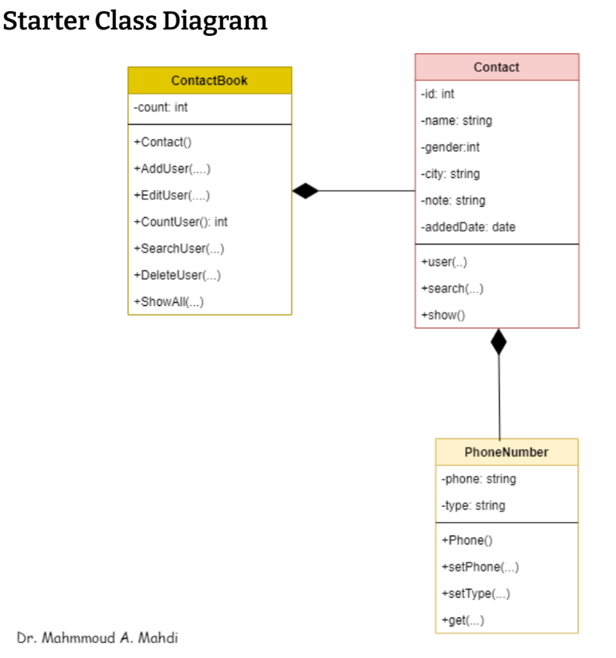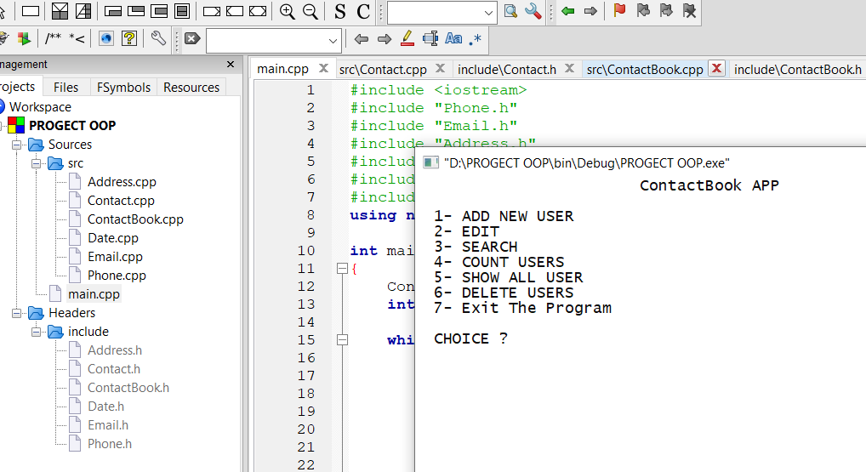

1 – Add New Uesr

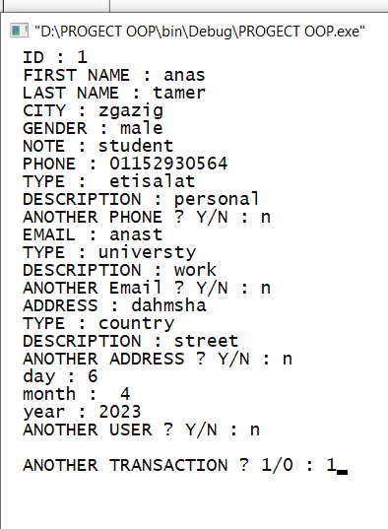

2 - Edit

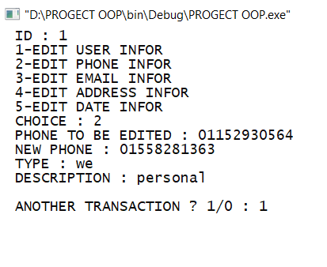

3 – Search

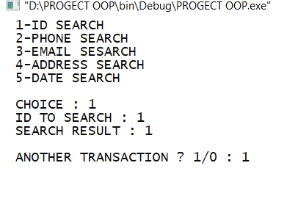

4 – Count User

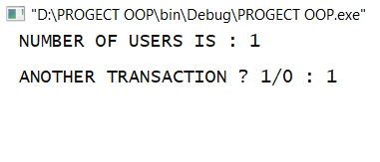

5 – Show All

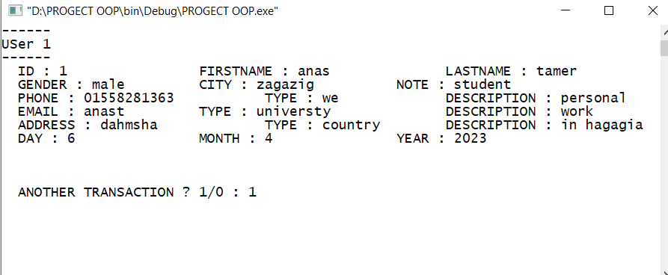

6 – Delete

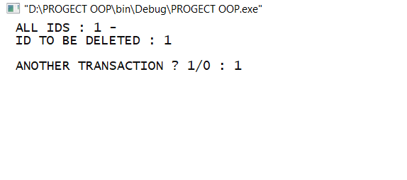

6 – Show after delete User

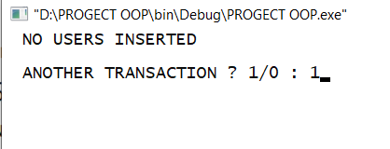

7 – Exit the program

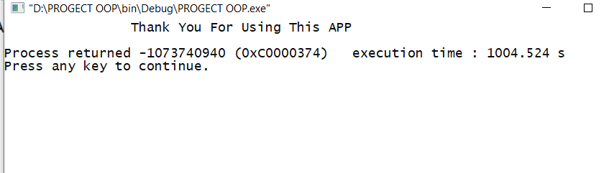

8 – Sort of Names and Show it

* Enter Data of User and show it
* First User

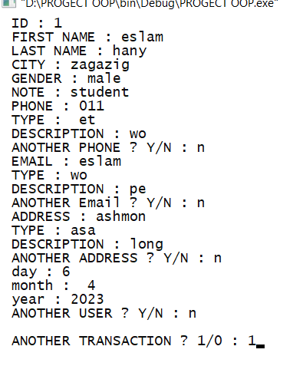

* Second User
* 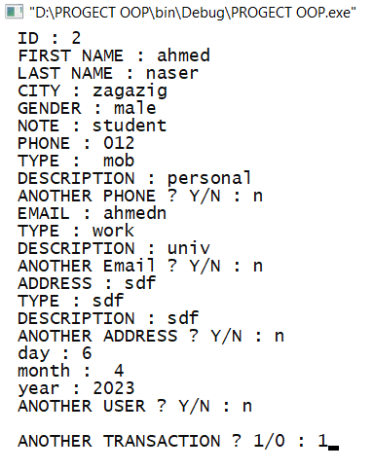

# Showing after Enter Data of Users and sort it

